THE SKELETAL SYSTEM REVISION

Label the diagram
Include names of ALL bones and create a key to highlight the classification of each bone

Label the synovial joint

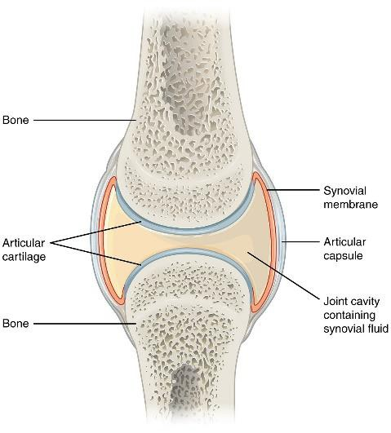AO1

Classification of joint | Description

Explain the role of synovial fluid and cartilage in a joint
Joint | Bones located here? | Movement which occurs here?
Head/neck
Shoulder
Chest
Elbow
Hip
Knee
Ankle

AO2

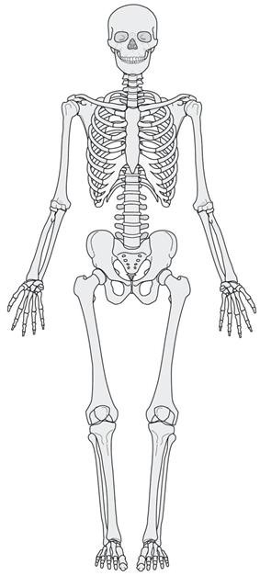Key Name the 2 different synovial joints and state their locations in
the body

1.
Function of skeleton | Description

2.
What are the 7 different types of
movement?
Movement | Description | Sporting Example

AO1 AO2

