THE RESPIRATORY SYSTEM REVISION
Label the spirometer diagram with tidal volume, inspiratory reserve volume, expiratory reserve volume, residual volume and vital capacity
Define each term

Label the diagram

Tidal Volume

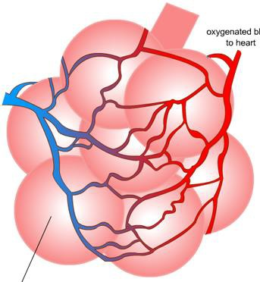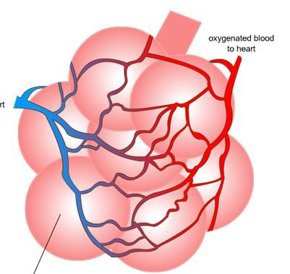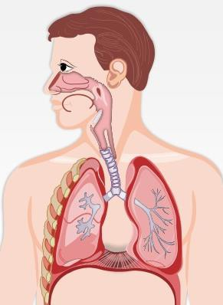Inspiratory reserve volume

Expiratory reserve volume

Vital Capacity

Residual
Volume

Characteristics of the alveoli

AO1

Explain the process of gaseous exchange

Explain what happens
during inspiration…

Explain what happens during exhalation…
AO1

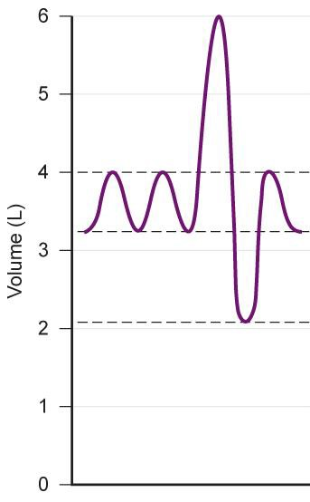Explain the changes that occur to inspiration during exercise (6 marks)
_
_
_
_
_
_
_
_
_
_
_
_

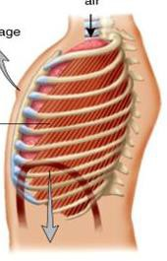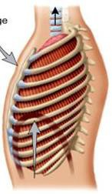AO2 AO3

