PLANES, AXIS AND LEVERS REVISION

KEY TERMS
Planes, axis
and
EXAM QUESTION (3marks)
Planes and axis work together to create sporting movements. Identify different sporting movements which happen in a combined plane and axis.
Write your answer here:

1.

2.

3.

PLANE

AXIS

1ST CLASS LEVER
2ND CLASS
LEVER
3RD CLASS LEVER

FULCRUM

LOAD
movement Write down what movements occur in each plane and
axis and a mnemonic to remember it by.
1.

Label the axis and plane on the diagrams above

2.

The diagram shows a basketball player jumping to execute a shot:
Draw the lever system that operates at the ankle in the space below. Label the fulcrum, effort, load resistance arm and effort arm.

Write down the equation for mechanical advantage.

Justify which levers a relay sprinter would use during a race
(6 marks)

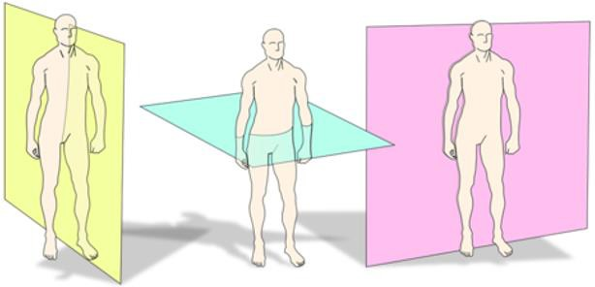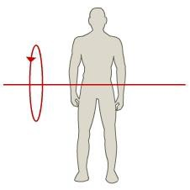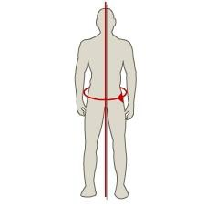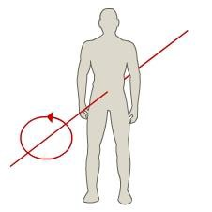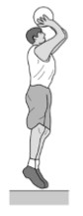EFFORT

RESISTANCE ARM EFFORT ARM

3.

Identify and label the lever systems above

AO1 AO2 AO3

