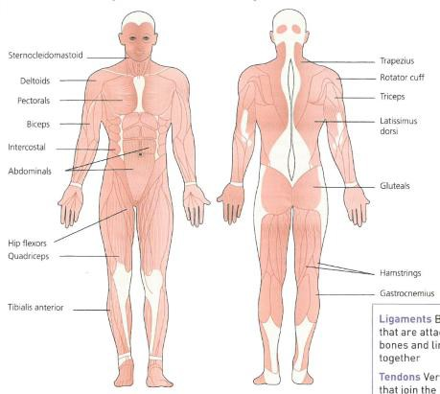THE MUSCULAR SYSTEM REVISION

Label the diagram

The origin is …
Movement | Agonist | Antagonist
Hip flexion
Hip extension
Elbow flexion
Elbow extension
Shoulder adduction
Shoulder abduction
Ankle plantar flexion
Ankle dorsi flexion

The insertion is …

Label the diagram with the
following … Origin Insertion Muscles Bones Agonist Antagonist

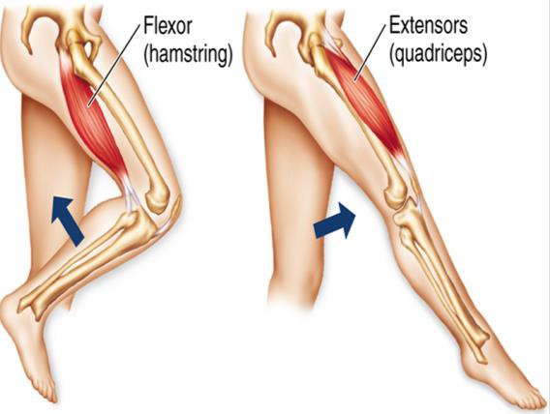AO1

Tendons connect
…

Ligaments connect
…

Explain the role of tendons during movement
Give three examples of an isometric muscle contraction in three different physical activities. Provide a justification for each answer (6 marks).

Isometric muscle contraction is:

Agonist is …
Location | Muscles involved?
Shoulder
Ankle
Elbow
Knee
Hip

Antagonist is …
Isotonic muscle contraction is: Eccentric muscle contraction is:
Concentric muscle contraction is:

AO1 AO2 AO3

