Edexcel
GCSE Physical Education

3. Physical Training
3.1 Health, Fitness & Exercise
3.2 Components of Fitness

Name:………………………………………………………………

Contents

3.1 Health, Fitness and Exercise……………………………………………5

3.2 Components of Fitness……………………………………………………7

Health-Related Components of Fitness
Body Composition……………………………………………………….8
Muscular Strength……………………………………………………….9
Flexibility………………………………………………………………..….11
Cardiovascular Endurance…………………………………..……..14
Muscular Endurance……………………………………………..……18
Re-cap of Health-Related Components of Fitness……….21

Skill-Related Components of Fitness
Agility……………………………………………….……………………..…22
Speed……………………………………………….…………………..……23
Balance……………………………………………….…………..…………25
Co-ordination…………………………………………………..….…….26
Power……………………………………………….…………..…………..28
Reaction Time………………………………………..…………….……30
Re-cap of Skill-Related Components of Fitness………....32

Interpreting Fitness Test Results………………………………………….33

9 Mark Questions – Steps to Success……………..…………………….34

9 Mark Questions – Model Answer……………..……………………….35

9 Mark Questions – Exam Style Question 1.……………..………….36

9 Mark Questions – Exam Style Question 2.……………..………….39

References
*Exam Style Questions – Taken from - Revise Edexcel GCSE (9-1) Physical Education – Revision Workbook
**9 Mark Questions – Steps to Success – Taken from Twitter
***9 Mark Questions – Exam Style Question 1 & 2 - Taken from - Revise Edexcel GCSE (9-1) Physical Education – Revision Workbook

Overview
Purpose

This booklet will provide you with a basic overview of the following sections:
- Health, Fitness and Exercise
- Components of Fitness

As well as aiding you towards your exams, it is essential that you understand these sections for your Personal Exercise Programme that makes up 10% of your overall qualification.

What will I need to do?

You will need to answer the questions provided throughout the booklet.

Your teacher will teach you each section and will then give you an opportunity to complete the booklet. Use the tips throughout the books and make sure you use your green pen to for corrections.

This booklet will be a fantastic resource for you to revise from if completed properly.

Personal Exercise Programme

Before participating in your Personal Exercise Programme (PEP), you will be asked to complete a series of fitness tests focused on in this unit of work and booklet. There are certain sections along the way to help think about what you might include in your PEP.

3.1 Health, Fitness and Exercise

Define ‘health’
________________________________________________________________________________________________________________________________________________________________________________________________
You may be asked to define these terms.

Define ‘fitness’
________________________________________________________________________________________________________________________________________________________________________________________________
Retrieval Practice

What is emotional well-being?
__________________________________________________

What is social well-being?
__________________________________________________

Homework
3. Physical training
3.1 Health and Fitness

Define ‘Exercise’
________________________________________________________________________________________________________________________________________________________________________________________________
How do health, fitness, exercise & performance impact one another?

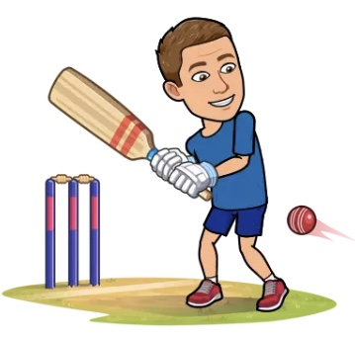
3.2 Components of Fitness
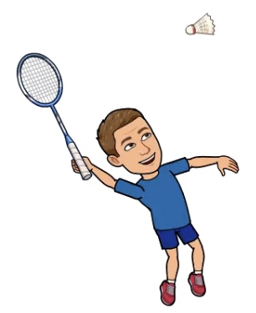
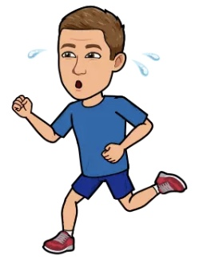

Fitness can be broken down into 11 components of fitness:

Skill-Related Components

A
B
C

P
R
S
Health-Related Components

B
M
F
C
M

Buy
Many
Football
Club
Managers
A B C P Q R S
Acronym
PEP

YOUR PEP will be focused on TWO of these Components of fitness.

PEP

You need to think about:
- What sport you will focus your PEP on?
- What position / role you play? (if applicable)
- What two CoF you will focus your PEP on.

Body Composition
Definition
________________________________________________________________________________________________________________________________________________________________________________________________
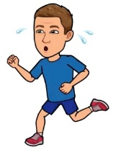
Sporting Examples
Identify two sporting athletes that would differ in body shape.

________________________________________________________________________
because…
Body shape would differ to a

Fitness Testing
Identify two ways to test body composition.
- ________________________________
- ________________________________
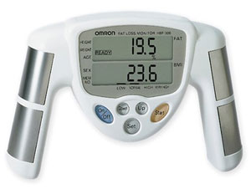
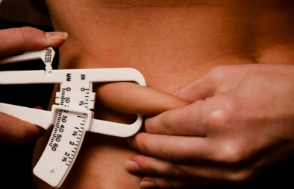
You are not expected to know how to test body composition for the exam, but you may want to test it as part of your PEP.

Research Task

https://www.topendsports.com/testing/bodycomp.htm

My Personal Exercise Programme (PEP)
Would you consider ‘body composition’ to be one of your Components of Fitness for your PEP? (tick one box).

Definitely Maybe Definitely not

If you do, research the skinfold callipers or Bioelectrical Impedance Analysis (BIA).

Muscular Strength
Definition
_______________________________________________________
_______________________________________________________
_______________________________________________________

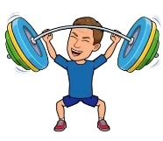
Sporting Examples
Justify = Provide an explanation or rationale
Identify = Can require a selection from a given stimulus or resource
Identify and justify two sports that would require muscular strength.

Sport One _______________________

Justification: ________________________________________________________________________________________________

Identify and justify two sports that would require muscular strength.

Sport Two _______________________

Justification: ________________________________________________________________________________________________

Fitness Testing
Identify the fitness test for muscular strength: ________________________________
What equipment do you need?

- _______________________

How do you do the test?
Step 1 - _______________________________________________
_____________________________________________________

Step 2 - _______________________________________________
_____________________________________________________

Step 3 - _______________________________________________
_____________________________________________________

Step 4 - _______________________________________________
_____________________________________________________

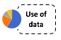

Normative Data
Identify what weight is; ‘Excellent’, ‘Average’ and ‘Poor’ for a male aged between 16-19 years-old?

Excellent - ...........................
Average -...............................
Poor - ...................................

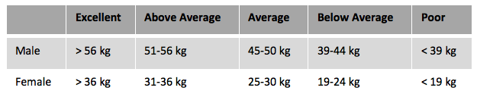

Source: Davis, B. et al., Physical Education and the Study of Sport, 4th edition, Harcourt, 2000.

Disadvantages of the Grip Dynamometer
Advantages of the Grip Dynamometer

It is essential that you can apply the knowledge to exam questions.
Exam Style Questions
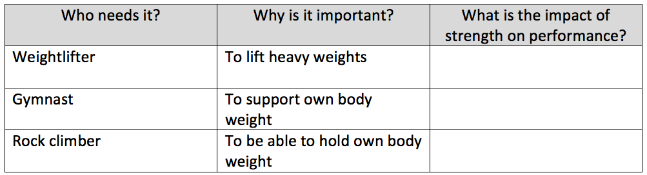
Stuck? I’ve got you started..
EXAM
ALERT
Figure 3 Footballer
2. What is the definition of ‘Body Composition’? (3 marks)
………………………………………………………………………………………………………………………………………………………………………………………
………………………………………………………………………………………………………………………………………………………………………………………
3. Complete the table to state the impact of strength on performance in the activities stated. (3 marks)

4. Briefly explain why strength is important to the player on the right of the picture in figure 3. (2 marks)
…………………………………………………………………………………………………………………………………………………
…………………………………………………………………………………………………………………………………………………
…………………………………………………………………………………………………………………………………………………
My Personal Exercise Programme (PEP)
Would you consider ‘Muscular Strength’ to be one of your Components of Fitness for your PEP? (tick one box).

Definitely Maybe Definitely not
Figure 2 Squash Player
Figure 1 Runner
1 a) Figure 1 and Figure 2 show two performers. Read the statements and highlight which is true. (1 mark)
A – Both performers use strength in their performance
B – Flexibility is not important to the runner.
C – Body composition is not relevant to the squash player
D – Strength Is more important than flexibility to the runner.

b) Give reasons for your choice (a) above. (2 marks)

Both performers use strength in their performance to generate force, the runner uses this force for a good start, the squash player uses it to………………………………………………………………………………………………………………………………………………………
…………………………………………………………………………………………………………………………………………………………………………………………..
…………………………………………………………………………………………………………………………………………………………………………………………..
…………………………………………………………………………………………………………………………………………………………………………………………..
2

2a

Flexibility
Definition
________________________________________________________________________________________________________________________________________________________________________________________________
Sporting Examples
Justify = Provide an explanation or rationale
Identify = Can require a selection from a given stimulus or resource
Identify and justify two sports that would require flexibility.

Sport One _______________________

Justification: ________________________________________________________________________________________________

Identify and justify two sports that would require flexibility.

Sport Two _______________________

Justification: ________________________________________________________________________________________________

Fitness Testing
Identify the fitness test for flexibility: ___________________________________
How do you do the test?
Step 1 - _______________________________________________
_____________________________________________________

Step 2 - _______________________________________________
_____________________________________________________

Step 3 - _______________________________________________
_____________________________________________________

Step 4 - _______________________________________________
_____________________________________________________

Step 5 - _______________________________________________
_____________________________________________________

Step 6 - _______________________________________________
_________________________________________________

Step 7 - _______________________________________________
_________________________________________________

What equipment do you need?

- _________________________
- _________________________

It is important your know the protocol for each test.

Homework
3. Physical training
3.2 Components of fitness

Normative Data
What distance is; ‘Average, ‘Excellent’ and ‘Above Average’ for a female, aged between 16 -19 years-old?

Average - ...................................
Excellent - ...................................
Above Average - ...................................

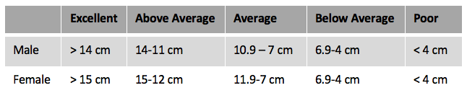

Advantages of the Sit & Reach Test
Disadvantages of the Sit & Reach Test

It is essential that you can apply the knowledge to exam questions.
Exam Style Questions
- . Define the term flexibility. (1 mark)
……………………………………………………………………………………………………………………………………………………………………………

- . a) Identify the most appropriate fitness test to measure flexibility. (Please tick one box) (1 mark)
- A – Vertical Jump Test
- B – Havard Step Test
- C – Sit and Reach Test
- D – Multi-Stage Fitness

b) Justify your answer by stating what components of fitness the other fitness test’s test. (2 marks)
…..… = …………………………………………………..
…..… = …………………………………………………..
…..… = …………………………………………………..

My Personal Exercise Programme (PEP)
Would you consider ‘Muscular Strength’ to be one of your Components of Fitness for your PEP? (tick one box).

Definitely Maybe Definitely not
Figure 3 Footballer
3. Flexibility is an important component of fitness for many activities. Complete the table below to explain how each performer uses flexibility in their activity. 4 marks)

- Explain the importance of a flexibility at the hip to the following performers. Use a different explanation for each performer.
- A gymnast in a floor routine (2 marks)
………………………………………………………………………………………………………………………………………………………………………..
…………………………………………………………………………………………………………………………………………………………………………
…………………………………………………………………………………………………………………………………………………………………………
- A hurdler during a race (2 marks)
…………………………………………………………………………………………………………………………………………………………………………….…………………………………………………………………………………………………………………………………………………………………………….………………………………………………………………………………………………………………………………………………………………

.

Who needs it? | How flexibility is used in activity
Sprinter | Flexibility is used at the hip to get a long stride length and therefore use as few strides as possible to complete the race in a quicker time.
Javelin Thrower | ……………………………………………………………………………………………………..  ……………………………………………………………………………………………………..  ……………………………………………………………………………………………………..  ……………………………………………………………………………………………………..
Stuck? I’ve got you started by doing the sprinter.
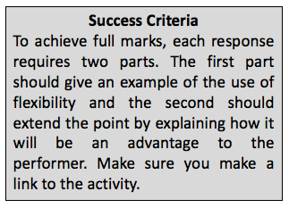

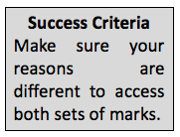

Try and stretch for 10 minutes a day.
It’ll have a big impact on your sporting performance!
My Personal Exercise Programme (PEP)
Would you consider ‘flexibility’ to be one of your Components of Fitness for your PEP? (tick one box).

Definitely Maybe Definitely not

Cardiovascular Endurance
Definition
________________________________________________________________________________________________________________________________________________________________________________________________
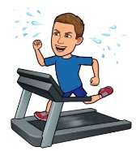
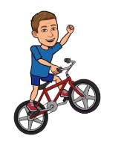
Sporting Examples
Identify = Can require a selection from a given stimulus or resource
Justify = Provide an explanation or rationale
Identify and justify two sports that would require Cardiovascular Endurance.

Sport Two _______________________

Justification: ________________________________________________________________________________________________

Identify and justify two sports that would require Cardiovascular Endurance.

Sport One _______________________

Justification: ________________________________________________________________________________________________

Fitness Testing
Identify a fitness test for cardiovascular endurance: ________________________________
How do you do the test?
Step 1 - _______________________________________________
_____________________________________________________

Step 2 - _______________________________________________
_____________________________________________________

Step 3 - _______________________________________________
_____________________________________________________

Step 4 - _______________________________________________
_____________________________________________________

What equipment do you need?
- ______________________
- ______________________
- ______________________
- ______________________

Homework
3. Physical training
3.2 Components of fitness

It is important your know the protocol for each test.

Normative Data
What distance is; ‘Excellent’, ‘Average’ and ‘Poor’ for a male runner aged between 15-16 years-old?

Excellent - ...................................
Average - ...................................
Poor - ...................................
Running
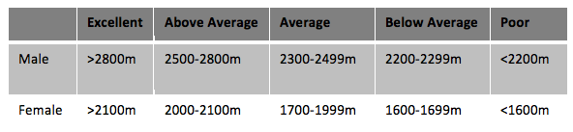

Source: www.brainmac.co.uk
What distance is; ‘Below Average, ‘Poor’ and ‘Above Average’ for a female swimmer, aged between 15-16 years-old?

Below Average - ............................
Poor - ............................
Above Average - .............................
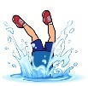
Swimming

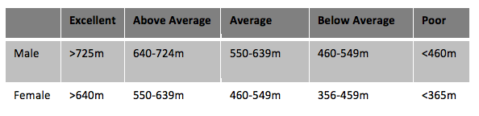

Source: Cooper, K.H., The Aerobics Program for Total Well-Being, Bantam Books, 1982. (Converted from yards to metres).
REMEMBER: Interpreting data / graphs is a key part of both exams.

Disadvantages of the Cooper Test
Advantages of the Cooper Test

Fitness Testing
Identify a fitness test for cardiovascular endurance: _____________________________
How do you do the test?
Step 1 - _______________________________________________
_____________________________________________________

Step 2 - _______________________________________________
_____________________________________________________

Step 3 - _______________________________________________
_____________________________________________________

Step 4 - _______________________________________________
_____________________________________________________

Step 5 - _______________________________________________
Between 1 and 1 ½ minutes after completing the test (Heart Beats 1)
Between 2 and 2 ½ minutes after completing the test (Heart Beats 2)
Between 3 and 3 ½ minutes after completing the test (Heart Beats 3)

What equipment do you need?
- ______________________
- ______________________
- ______________________
- ______________________

What is the formula to calculate your level of fitness?

Normative Data
What heart rate is; ‘Average, ‘Excellent’ and ‘Above Average’ for a female, aged between 16 years-old?

Average - ...................................
Excellent - ...................................
Above Average - ...................................
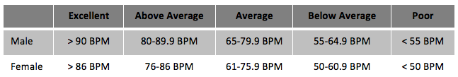

Source: Beashel, P. and Taylor, J., The World Sport Examined, Thomas Nelson and Sons, 1997.

Disadvantages of the Harvard Step Test

Advantages of the Harvard Step Test

My Personal Exercise Programme (PEP)
Would you consider ‘cardiovascular endurance’ to be one of your Components of Fitness for your PEP? (tick one box).

Definitely Maybe Definitely not

It is essential that you can apply the knowledge to exam questions.
Exam Style Questions
- Which one of the following is a test of cardiovascular fitness? (1 mark)
A – Vertical Jump Test
B – Sit and Reach Test
C – 30m Sprint Test
D – Havard Step Test

- Describe the test protocol for the Cooper 12-minute test. (4 marks)
To complete the Cooper 12-minute swim test, you need to work with a partner: one swims, and one counts the number of lengths………………………………………………………………………………………………………………………………………………………………………..
…………………………………………………………………………………………………………………………………………………………………………………………
…………………………………………………………………………………………………………………………………………………………………………………………

Stuck? I’ve got you started..

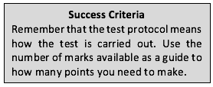
EXAM
ALERT

- a) Give an example of a performer who would use the Harvard step test to measure their fitness for their sport, stating why this would be an appropriate test for them. (2 marks)

……………………………………………………………………………………………………………………………………………………………………………………
……………………………………………………………………………………………………………………………………………………………………………………
……………………………………………………………………………………………………………………………………………………………………………………
b) State why performers should test their fitness at the start and then again at the end of their training programme.
(1 mark)
……………………………………………………………………………………………………………………………………………………………………………………
……………………………………………………………………………………………………………………………………………………………………………………
……………………………………………………………………………………………………………………………………………………………………………………

- Elad and Stuart play water polo. Before starting a training programme they take part in several fitness tests.

- Identify the most appropriate fitness test to measure the boys’ cardiovascular fitness. (1 mark)
……………………………………………………………………………………………………………………………………………………………………….
- Give a reason for selecting this test. (1 mark)
……………………………………………………………………………………………………………………………………………………………………….
……………………………………………………………………………………………………………………………………………………………………….

Muscular Endurance
Definition
_______________________________________________________
_______________________________________________________
_______________________________________________________

Sporting Examples
Justify = Provide an explanation or rationale
Identify = Can require a selection from a given stimulus or resource
Identify and justify two sports that would require muscular endurance.

Sport One _______________________

Justification: ________________________________________________________________________________________________

Identify and justify two sports that would require muscular endurance.

Sport Two _______________________

Justification: ________________________________________________________________________________________________

Fitness Testing
Identify a fitness test for Muscular Endurance: __________________________
What equipment do you need?
- _______________________
- _______________________
- _______________________

How do you do the test?
Step 1 - _______________________________________________
_____________________________________________________

Step 2 - _______________________________________________
_____________________________________________________

Step 3 - _______________________________________________
_____________________________________________________

Normative Data
What figure is; ‘Below Average, ‘Average’ and ‘Above Average’ for a female aged between 16-19 years-old?

Below average - ...................................
Average - ...................................
Above average - ...................................

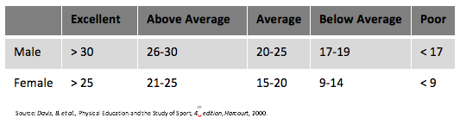

Disadvantages of the One-Minute Sit-up Test

Advantages of the One-Minute Sit-up Test

Fitness Testing
Identify a fitness test for muscular endurance: ______________________________
What equipment do you need?
- _______________________
- _______________________

How do you do the test?
Full Press-up - ____________________________________________________
_____________________________________________________
Modified Press-up ____________________________________________________
_____________________________________________________
- __________________________________________________
- __________________________________________________

Normative Data
What figure is; ‘Good ‘, ‘Very poor’, and ‘Above Average’ for an individual completing full press ups, aged between 17-19 years-old?

Below average - ...................................
Average - ...................................
Above average - ...................................

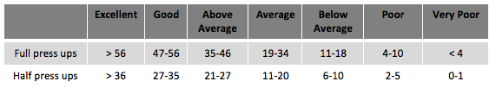

Source: Golding, L.A et al., The Y’s way to Physical Fitness, 3rd edition, 1986.

Disadvantages of the One-Minute Press-up Test

Advantages of the One-Minute Press-up Test

BE CAREFUL!

It is ALWAYS important to read the question more than once. Some questions can have a lot of text!
’ Top Tip
Exam Style Questions
- Carolyn would like to improve her volleyball performance she has noticed that her arms get tired in the second half of a game.
Carolyn designs a training programme to improve her performance and has selected some fitness tests that she will complete at the beginning and the end of a training programme.

- If Carolyn already knows what her areas for improvement are, give a reason why she should still complete fitness test. (1 mark)

………………………………………………………………………………………………………………………………………………………………………………
- Identify the fitness test being complete by Carolyn in figure 1. (1 mark)

……………………………………………………………………………………………………………………………………………………………………………..

- State why Carolyn’s choice of fitness test is appropriate. (2 marks)
Because it tests …………………………………………….. which is needed as she will use repeated muscle contractions during her match. It also focuses on……………………………………………………………………………
………………………………………………………………………………………………………………………………………………………
……………………………………………………………………………………………………………………………………………………………
……………………………………………………………………………………………………………………………………………………………

It is essential that you can apply the knowledge to exam questions.
Figure 1

Stuck? I’ve got you started

These 3 fantastic resources will help you access an excellent grade in GCSE PE.

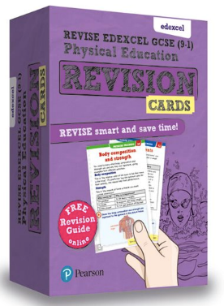
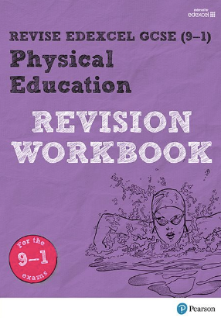

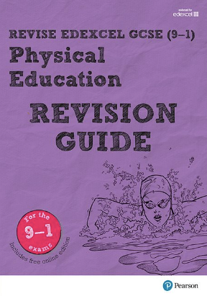
My Personal Exercise Programme (PEP)
Would you consider ‘muscular endurance’ to be one of your Components of Fitness for your PEP? (tick one box).

Definitely Maybe Definitely not

https://www.pearsonschoolsandfecolleges.co.uk/

Task 1
Identify the Components of Fitness.
Hint: Definitions and sporting examples have been provided.

Task 2
Identify a sport related to the component of fitness.
Hint: Look at the picture in the circle above.

……………..

…………….……

…………….……

…………….….
………………..

…………….
………………………………………
……………………………………………….……
………………………………………………
………………………………………
………………………………………

Agility
Definition
_______________________________________________________
_______________________________________________________
_______________________________________________________

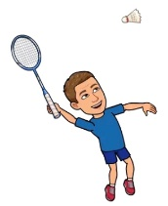
Sporting Examples
Justify = Provide an explanation or rationale
Identify = Can require a selection from a given stimulus or resource
Identify and justify two sports that would require agility.

Sport One _______________________

Justification: ________________________________________________________________________________________________

Identify and justify two sports that would require agility.

Sport Two _______________________

Justification: ________________________________________________________________________________________________

Fitness Testing
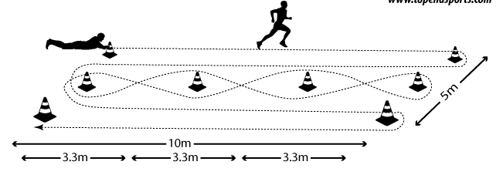
Identify the fitness test for agility: _______________________________
You are not expected to know how to test agility for the exam, but you may want to test it as part of your PEP.

Research Task

https://www.topendsports.com/testing/tests/illinois.htm

My Personal Exercise Programme (PEP)
Would you consider ‘agility’ to be one of your Components of Fitness for your PEP? (tick one box).

Definitely Maybe Definitely not
If you do, research the Illinois Agility Run Test.

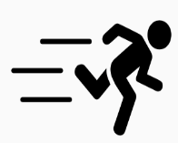
Speed
Definition
_______________________________________________________
_______________________________________________________
_______________________________________________________

Speed =

Sporting Examples
Justify = Provide an explanation or rationale
Identify = Can require a selection from a given stimulus or resource
Identify and justify two sports that would require speed.

Sport One _______________________

Justification: ________________________________________________________________________________________________

Identify and justify two sports that would require speed.

Sport Two _______________________

Justification: ________________________________________________________________________________________________

Fitness Testing
Identify the fitness test for speed: ________________________________
What equipment do you need?
- _______________________
- _______________________
- _______________________
- _______________________
- _______________________

How do you do the test?
Step 1 - _______________________________________________
_____________________________________________________

Step 2 - _______________________________________________
_________________________________________________

Step 3 - _______________________________________________
_____________________________________________________

Step 4 - _______________________________________________
_____________________________________________________

Normative Data
What speed is; ‘Poor, ‘Average’ and ‘Above Average’ for a male, aged between 16 -19 years-old?

Average - ...................................
Excellent - ...................................
Above Average - ...................................

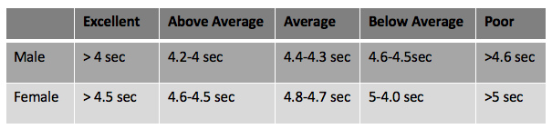

Source: Davis, B. et al., Physical Education and the Study of Sport, 4th edition, Harcourt, 2000.

Disadvantages of the 30m sprint test

Advantages of the 30m sprint test

My Personal Exercise Programme (PEP)
Would you consider ‘speed’ to be one of your Components of Fitness for your PEP? (tick one box).

Definitely Maybe Definitely not

It is essential that you can apply the knowledge to exam questions.
Exam Style Questions
1 a) Identify one way in which the 30-metre sprint test is different from the Illinois agility test. (1 mark)
………………………………………………………………………………………………………………………………………
………………………………………………………………………………………………………………………………………

b) Explain how this variation makes the test more relevant for their particular use. (2 marks)

……………………………………………………………………………………………………………………………………………………………………………
……………………………………………………………………………………………………………………………………………………………………………
……………………………………………………………………………………………………………………………………………………………………………
(c) i) State two different activities that would be suitable for an individual who achieved an ‘excellent’ rating in the 30-metre sprint test. (2 marks)

……………………………………………………………………………………………………………………………………………………………………………
……………………………………………………………………………………………………………………………………………………………………………
ii) For each of these activities stat how speed would be an advantage.

……………………………………….: speed over a short distance is really helpful to beat your opponent to the …………………
……………………………………………………………………………………………………………………………………………………………………………
……………………………………………………………………………………………………………………………………………………………………………
2) a) Identify the fitness test for agility and
b) State an activity where the performers would
find the results of this test useful. (2 marks)

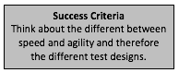

Stuck? I’ve got you started…

- ………………………………………………………………………..
- ………………………………………………………………………..

Balance
Definition
_______________________________________________________
_______________________________________________________
_______________________________________________________

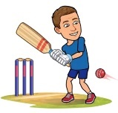
Sporting Examples
Justify = Provide an explanation or rationale
Identify = Can require a selection from a given stimulus or resource
Identify and justify ONE sport that would require static balance.

Sport One _______________________

Justification: ________________________________________________________________________________________________

Identify and justify ONE sport that would require dynamic balance.

Sport Two _______________________

Justification: ________________________________________________________________________________________________

Fitness Testing
Identify the fitness test for balance: _______________________________
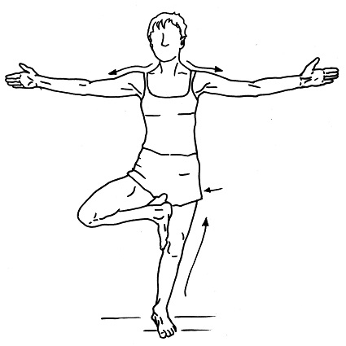
You are not expected to know how to test balance for the exam, but you may want to test it as part of your PEP.

Research Task

https://www.topendsports.com/testing/tests/balance-stork.htm

My Personal Exercise Programme (PEP)
Would you consider ‘balance’ to be one of your Components of Fitness for your PEP? (tick one box).

Definitely Maybe Definitely not
If you do, research the Standing Stork Test.

Co-ordination
Definition
_______________________________________________________
_______________________________________________________
_______________________________________________________

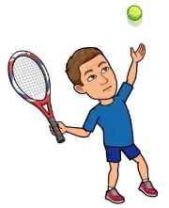
Sporting Examples
Justify = Provide an explanation or rationale
Identify = Can require a selection from a given stimulus or resource
Identify and justify two sports that would require co-ordination.

Sport One _______________________

Justification: ________________________________________________________________________________________________

Identify and justify two sports that would require co-ordination.

Sport Two _______________________

Justification: ________________________________________________________________________________________________

Fitness Testing
Identify the fitness test for co-ordination: _______________________________
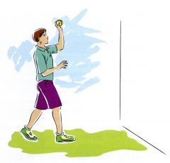
You are not expected to know how to test co-ordination for the exam, but you may want to test it as part of your PEP.

Mr Richards’ Top Tip

Research Task

https://www.brianmac.co.uk/handeye.htm

My Personal Exercise Programme (PEP)
Would you consider ‘co-ordination’ to be one of your Components of Fitness for your PEP? (tick one box).

Definitely Maybe Definitely not
If you do, research the Alternate Hand Toss Test.

It is essential that you can apply the knowledge to exam questions.
Exam Style Questions
- Which of the following components of fitness is the most important in the yoga pose shown in figure 1?
A – Balance (1 mark)
B – Co-ordination
C – Strength
D – Body Composition

- a) Identify the type of balance being used by the performer with the ball in figure 2.
………………………………………………………………………………………………………………………

b) State how the player in figure 2 is using this type of balance to improve their performance in their sport.
(2 marks)
………………………………………………………………………………………………………………………………………………………………………..
………………………………………………………………………………………………………………………………………………………………………..

- Which one of the following statements gives the most accurate description of co-ordination? (tick a circle)
- A movement that only requires the movement of one body part with control
- A static or dynamic movement where the body’s centre of mass is central
- A movement using two or more body parts at the same time
- Two movements in a sequence carried out with control (1 mark)

- Explain why any technique in sport is normally performed to a higher standard if it is performed with a high level of co-ordination. (3 marks)
A co-ordinated movement will be efficient, smooth and therefore………………………………………………………………..
……………………………………………………………………………………………………………………………………………………………………
……………………………………………………………………………………………………………………………………………………………………
……………………………………………………………………………………………………………………………………………………………………

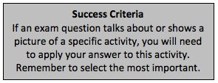
EXAM
ALERT
Figure 1

Figure 2

Stuck? I’ve got you started…

BE CAREFUL!

Multiple choice questions can often ‘trip’ people up. Make sure you read each statement at least twice. The wording will be similar but not quite the same.

V

Spend 30 minutes on Seneca a day to secure the knowledge you have learnt so far.
Mr Richards’ Top Tip

Power
Definition
_______________________________________________________
_______________________________________________________
_______________________________________________________

Sporting Examples
Justify = Provide an explanation or rationale
Identify = Can require a selection from a given stimulus or resource
Identify and justify two sports that would require power.

Sport One _______________________

Justification: ________________________________________________________________________________________________

Identify and justify two sports that would require power.

Sport Two _______________________

Justification: ________________________________________________________________________________________________

Fitness Testing
Identify the fitness test for power: ________________________________
How do you do the test?
Step 1 - _______________________________________________
_________________________________________________
_________________________________________________

Step 2 - _______________________________________________
_________________________________________________
_________________________________________________

Step 3 - _______________________________________________
_________________________________________________
_________________________________________________

What equipment do you need?
- _______________________
- _______________________
- _______________________
- _______________________

Normative Data
What distance is; ‘Below average, ‘Average’ and ‘Excellent’ for a female, aged between 16 -19 years-old?

Average - ...................................
Excellent - ...................................
Above Average - ...................................

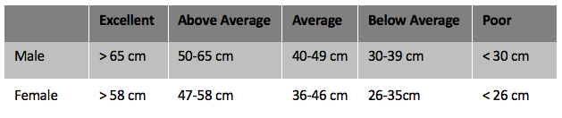
Source: Davis, B. et al., Physical Education and the Study of Sport, 4th edition, Harcourt, 2000.

Disadvantages of the Vertical Jump Test

Advantages of the Vertical Jump Test

My Personal Exercise Programme (PEP)
Would you consider ‘power’ to be one of your Components of Fitness for your PEP? (tick one box).

Definitely Maybe Definitely not

It is essential that you can apply the knowledge to exam questions.
Exam Style Questions
1) Identify the component of fitness being described.
‘The rate at which an individual is able to perform a movement or cover a distance in a period of time.’
…………………………………………………………………………………………………………………………… (1 mark)

2) In the table, describe how each performer uses speed and what its effect is on performance. (6 marks)

3) Explain the use of power for both the javelin (figure 1) and tennis player (figure 2). (4 marks)

……………………………………………………………………………………………………………………………………………………………………………
……………………………………………………………………………………………………………………………………………………………………………
……………………………………………………………………………………………………………………………………………………………………………

Be Careful! Read the statement at least twice!

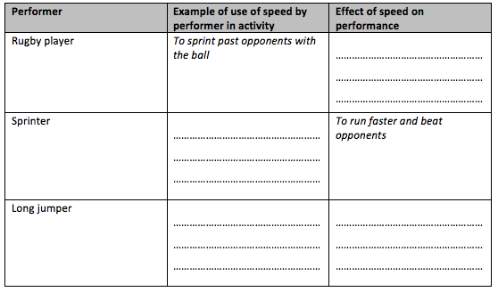
Stuck? I’ve got you started…
Figure 2
Figure 1

Reaction Time
Definition
_______________________________________________________
_______________________________________________________
_______________________________________________________

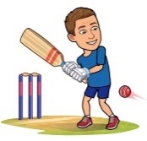
Sporting Examples
Justify = Provide an explanation or rationale
Identify = Can require a selection from a given stimulus or resource
Identify and justify two sports that would require reaction time.

Sport One _______________________

Justification: ________________________________________________________________________________________________

Identify and justify two sports that would require reaction time.

Sport Two _______________________

Justification: ________________________________________________________________________________________________

Fitness Testing
Identify the fitness test for reaction time: _______________________________
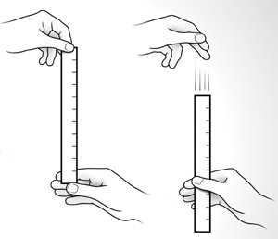
You are not expected to know how to test reaction time for the exam, but you may want to test it as part of your PEP.

Research Task

https://www.brianmac.co.uk/rulerdrop.htm

My Personal Exercise Programme (PEP)
Would you consider ‘reaction time’ to be one of your Components of Fitness for your PEP? (tick one box).

Definitely Maybe Definitely not
If you do, research the Ruler Drop Test.

It is essential that you can apply the knowledge to exam questions.
Exam Style Questions
1) Using an example from a sport of your choice, describe what is meant by the term reaction time. (2 marks)
……………………………………………………………………………………………………………………………………………………………………….
……………………………………………………………………………………………………………………………………………………………………….
2) Place in order the importance of reaction time to performers in the following activities and justify your order. (6 marks)
- Midfielder in a team game
- Gymnast completing a floor routine
- 100-metre sprinter

3) Figure 1 shows a goalkeeper diving for the ball. Using figure 1, explain the importance of reaction time to the goalkeeper. (3 marks)

The goalkeeper will need good reaction time when a shot has been deflected off a defender. This is because…..
…………………………………………………………………………………………………………………………………………………………………………
…………………………………………………………………………………………………………………………………………………………………………
…………………………………………………………………………………………………………………………………………………………………………

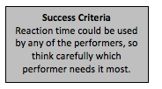

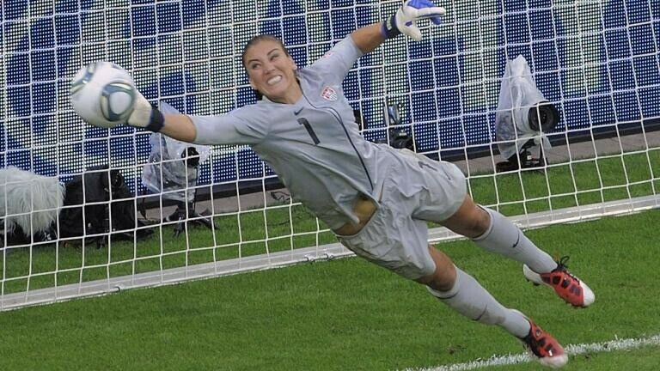
EXAM
ALERT

Figure 1
Stuck? I’ve got you started…

https://www.pearsonschoolsandfecolleges.co.uk/

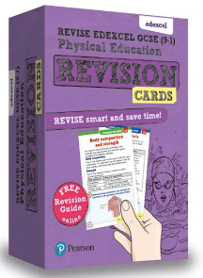

https://www.pearsonschoolsandfecolleges.co.uk/

These 3 fantastic resources will help you access an excellent grade in GCSE PE.

Task 2
Identify a sport related to the component of fitness.
Hint: Look at the picture in the circle above.

Task 1
Identify the Components of Fitness.
Hint: Definitions and sporting examples have been provided.

SKILL RELATED COMPONENTS OF FITNESS

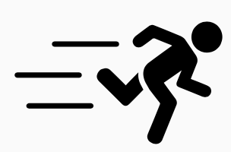

……………………..
……………………..
……………………..
……………………..
……………………..
……………………..

Netball
Shot put
Football
‘the amount of time it takes to perform a particular action or cover a distance’
‘the ability to do strength performances quickly.’
Speed x strength
‘the ability to change the position of the body quickly, while maintaining control of the movement’
‘the ability to use two or more body parts together.’
‘the ability to retain the body’s centre of mass above the base of support’.
‘the time it takes to respond to a stimulus.’
………………..
100m
200m
Boxing
………………..
………………..
………………..
………………..
………………..
Interpreting Fitness Test Results
Mason the Rugby Player
Mason plays rugby for the school team. he designed his personal exercise programme (PEP) around improving his fitness for rugby. Mason completed fitness tests before he stated his training programme and also once a week throughout training to monitor his progress.
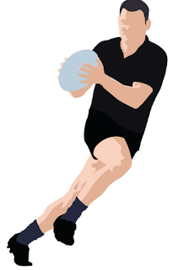

EXAM
ALERT

Summary of Mason’s fitness test results
Test/rating | Before PEP | During PEP |  |  |  | After PEP
 | 4 Sept | 11 Sept | 18 Sept | 25 Sept | 2 Oct | 9 Oct
One-minute sit up | 32 | 34 | 35 | 37 | 38 | 38
Rating | Below average
Vertical jump test | 48 | 49 | 50 | 54 | 58
Rating | Average | Average | Good | Good | Good | Excellent
Harvard step test | 76 | 78 |  | 85 | 87
Rating | Average | Average |  | Above average | Above average
One-minute sit-up test normative data
Vertical jump test normative data
Havard step test normative data

Rating | Number of reps
Excellent | >49
Good | 43-48
Above Average | 39-42
Average | 35-38
Below Average | 31-34
Poor | <30
Rating | Number of reps
Excellent | >60
Good | 50-60
Average | 40-49
Fair | 30-39
Poor | <30
Rating | Number of reps
Excellent | >90
Above Average | 80-89
Average | 65-79
Below Average | 55-64
Poor | <55

- (a) Using the normative data tables, complete the rating for the one-minute sit-up test. (1 mark)

(b) Identify the score Mason must have achieved to get an excellent rating for the vertical jump test. (1 mark)
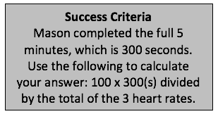
………………………………………………………………………………………………………………………………………………………
(c) Mason stepped for the full five minutes each time he took the Harvard step test.
(i) Calculate Mason’s missing results when his heart rates were:
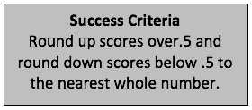
18 Sept: 130, 125, 120 ……………………………
(2 marks)

9 Oct: 120, 110, 100 ……………………………….

(ii) Using Mason’s Harvard step test scores from (c) (i), identify his ratings for this test and add them to the table. (2 marks)
(d) Analyse Mason’s one-minute sit-up test results. (3 marks)
Stuck? I’ve got you started…
Mason started below average and after six weeks ………………………………………………………………………………….
………………………………………………………………………………………………………………………………………………………………………..…………………………………………………………………………………………………………………………………………………….…………………..…

9 Mark Questions – Steps to Success
STEP 1: READ THE QUESTION carefully and HIGHLIGHT the following words:
Command Word: What is the question asking you to do? (Discuss, Analyse, Evaluate, Justify?)
Topic Word: This should provide the content for your answer, the question is asking you to demonstrate knowledge of this area of the specification e.g. guidance
Qualifying Word – this provides the context. This is what you will be linking your answer to e.g. improving sports performance

STEP 2: PLAN and STRUCTURE your answer. Ensure you include the following:
Introduction - give an overview of the topic. Think about re-wording the question and demonstrating knowledge and understanding of the topic
Main Body –3 paragraphs (1 x A01, 1 x A02, 1 x A03 IN EACH PARAGRAPH)
Conclusion – Summarise your answer
*Don’t forget to use paragraphs!*

Annotate the question as your plan!

Make a POINT (AO1)
3 MARKS
STEP 3, 4 & 5 REPEAT THIS STEP 3 TIMES (3 Paragraphs)
A01: Demonstrate knowledge and understanding – define, identify, state, outline, describe.

A02: Apply knowledge and understanding using sporting examples - demonstrate your understanding of HOW the topic links/applies to a sporting example

A03: Analyse and evaluate – explore and review the information you have provided, bringing it together to form a conclusion or judgement. Articulate contrasting viewpoints, look at advantages/disadvantages, strengths/weaknesses.

Explain it using a sporting example (AO2) 3 MARKS

Analyse and Evaluate (AO3)
3 MARKS

You should spend 15 minutes on each 9 mark questions.
STEP 6: CUPS your work
Capitals
Understanding
Punctuation
Spelling

Remember to use key vocabulary and terminology throughout your answer

How do I answer the paper...?
1st – 9 mark question (BEST)
2nd – 9 mark question
3rd – Multiple choice
4th – Short answer questions
9 Mark Model Answer
Figure 11 show a tennis player during a match. Assess the importance of muscular endurance, flexibility and speed on performance in a tennis match. (9 marks)

PLAN:

Small intro
Paragraph – M E
Paragraph – F
Paragraph – S
Conclusion – Most useful / other Cof

SPORTING KNOWLEDGE

In order to access top marks in this question, you must have good knowledge & understanding of tennis.

Research a range of sports to ensure you are prepared for any question!

Figure 11
A tennis player would require muscular endurance, flexibility and speed throughout different stages of a tennis match.

Muscular endurance is the ability to use the same muscle group repeatedly for a long period of time without tiring. It is important in tennis as it allows repeated contraction of the arm muscles to carry on striking the ball with pace and accuracy.

Speed can relate to the whole body or a body part, and it relates to the quickness of a movement. It is important in tennis to move around the court: for example, chasing a drop shot if you are at the back of the court.

Flexibility is the range of movement possible at the joint. This is important to the tennis player because it allows a better range of movement at the joint, so the player can generate more power when striking the ball, making it harder for the opponent to return.

As seen, all three components are important and they can offer some advantage to the player – if they lacked any of these components they would not be able to play as well, the quality of their play would drop, they would not have the pace to return a shot or would not be able to generate so much pace on the ball.

However, without muscular endurance they would always lose the second or third set, therefore this must be the most important as without their speed and power would be irrelevant as they would already be out of the match. Provided they had average flexibility, speed would probably be more of an asset, as their opponent will be trying to place the ball away from them and they will need to be quick to get it.

Small Intro
=
Notice how this is written in 3 paragraphs!

AO1
AO2

AO1
AO2

AO1

AO3

AO3 - review

AO3 – Knowledge of CoF
9/9
AO3 – judge-ment
Your Turn
Figure 12 show a basketball player during a match. Assess the importance of cardiovascular endurance, agility and balance on performance in a basketball match. (9 marks)

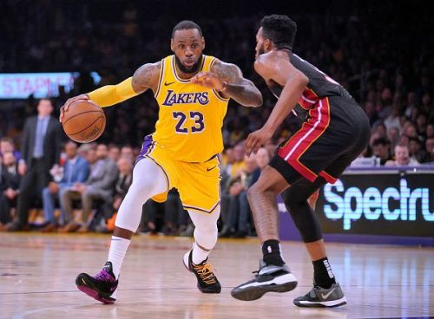
PLAN:

Figure 12

………………………………………………………………………………………………………………………….
………………………………………………………………………………………………………………………….
………………………………………………………………………………………………………………………….
………………………………………………………………………………………………………………………….
………………………………………………………………………………………………………………………….
………………………………………………………………………………………………………………………….
………………………………………………………………………………………………………………………….
………………………………………………………………………………………………………………………….
………………………………………………………………………………………………………………………….
………………………………………………………………………………………………………………………….
………………………………………………………………………………………………………………………….
………………………………………………………………………………………………………………………….
………………………………………………………………………………………………………………………….
………………………………………………………………………………………………………………………….
………………………………………………………………………………………………………………………….
………………………………………………………………………………………………………………………….
………………………………………………………………………………………………………………………….
………………………………………………………………………………………………………………………….
………………………………………………………………………………………………………………………….
………………………………………………………………………………………………………………………….
………………………………………………………………………………………………………………………….
………………………………………………………………………………………………………………………….
………………………………………………………………………………………………………………………….
………………………………………………………………………………………………………………………….
………………………………………………………………………………………………………………………….
………………………………………………………………………………………………………………………….
………………………………………………………………………………………………………………………….
………………………………………………………………………………………………………………………….
………………………………………………………………………………………………………………………….
………………………………………………………………………………………………………………………….
………………………………………………………………………………………………………………………….
………………………………………………………………………………………………………………………….
………………………………………………………………………………………………………………………….
………………………………………………………………………………………………………………………….
………………………………………………………………………………………………………………………….
………………………………………………………………………………………………………………………….
………………………………………………………………………………………………………………………….
………………………………………………………………………………………………………………………….
………………………………………………………………………………………………………………………….
………………………………………………………………………………………………………………………….
………………………………………………………………………………………………………………………….
………………………………………………………………………………………………………………………….
………………………………………………………………………………………………………………………….
………………………………………………………………………………………………………………………….
………………………………………………………………………………………………………………………….
………………………………………………………………………………………………………………………….
………………………………………………………………………………………………………………………….
………………………………………………………………………………………………………………………….
………………………………………………………………………………………………………………………….
………………………………………………………………………………………………………………………….
………………………………………………………………………………………………………………………….
………………………………………………………………………………………………………………………….
………………………………………………………………………………………………………………………….
………………………………………………………………………………………………………………………….
………………………………………………………………………………………………………………………….
………………………………………………………………………………………………………………………….
………………………………………………………………………………………………………………………….
………………………………………………………………………………………………………………………….
………………………………………………………………………………………………………………………….
………………………………………………………………………………………………………………………….
………………………………………………………………………………………………………………………….
………………………………………………………………………………………………………………………….
………………………………………………………………………………………………………………………….
………………………………………………………………………………………………………………………….
………………………………………………………………………………………………………………………….
………………………………………………………………………………………………………………………….
………………………………………………………………………………………………………………………….
………………………………………………………………………………………………………………………….
………………………………………………………………………………………………………………………….
(9 marks)

Your Turn
Figure 13 shows two canoeists during a competition.
To do well in competition, canoeists need good strength, flexibility and speed.

Table 6 shows the fitness tests these canoeists used to assess their fitness.

Discuss the suitability of using the fitness tests shown in table 6 to assess the fitness of the canoeists for their sport. (9 marks)

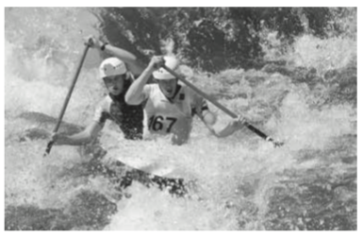

Figure 13

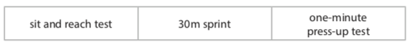
Table 6

PLAN:

NOTICE HOW THIS QUESTION IS DIFFERENT…?

- Go through the same routine (p.g. 34 & 35)
- What is the question asking you to do?
- Link the fitness tests to components of fitness
- Link the fitness test / CoF to the sport.

………………………………………………………………………………………………………………………….
………………………………………………………………………………………………………………………….
………………………………………………………………………………………………………………………….
………………………………………………………………………………………………………………………….
………………………………………………………………………………………………………………………….
………………………………………………………………………………………………………………………….
………………………………………………………………………………………………………………………….
………………………………………………………………………………………………………………………….
………………………………………………………………………………………………………………………….
………………………………………………………………………………………………………………………….
………………………………………………………………………………………………………………………….
………………………………………………………………………………………………………………………….
………………………………………………………………………………………………………………………….
………………………………………………………………………………………………………………………….
………………………………………………………………………………………………………………………….
………………………………………………………………………………………………………………………….
………………………………………………………………………………………………………………………….
………………………………………………………………………………………………………………………….
………………………………………………………………………………………………………………………….
………………………………………………………………………………………………………………………….
………………………………………………………………………………………………………………………….
………………………………………………………………………………………………………………………….
………………………………………………………………………………………………………………………….
………………………………………………………………………………………………………………………….
………………………………………………………………………………………………………………………….
………………………………………………………………………………………………………………………….
………………………………………………………………………………………………………………………….
………………………………………………………………………………………………………………………….
………………………………………………………………………………………………………………………….
………………………………………………………………………………………………………………………….
………………………………………………………………………………………………………………………….
………………………………………………………………………………………………………………………….
………………………………………………………………………………………………………………………….
………………………………………………………………………………………………………………………….
………………………………………………………………………………………………………………………….
………………………………………………………………………………………………………………………….
………………………………………………………………………………………………………………………….
………………………………………………………………………………………………………………………….
………………………………………………………………………………………………………………………….
………………………………………………………………………………………………………………………….
………………………………………………………………………………………………………………………….
………………………………………………………………………………………………………………………….
………………………………………………………………………………………………………………………….
………………………………………………………………………………………………………………………….
………………………………………………………………………………………………………………………….
………………………………………………………………………………………………………………………….
………………………………………………………………………………………………………………………….
………………………………………………………………………………………………………………………….
………………………………………………………………………………………………………………………….
………………………………………………………………………………………………………………………….
………………………………………………………………………………………………………………………….
………………………………………………………………………………………………………………………….
………………………………………………………………………………………………………………………….
………………………………………………………………………………………………………………………….
………………………………………………………………………………………………………………………….
………………………………………………………………………………………………………………………….
………………………………………………………………………………………………………………………….
………………………………………………………………………………………………………………………….
………………………………………………………………………………………………………………………….
………………………………………………………………………………………………………………………….
(9 marks)

