THE CIRCULATORY SYSTEM REVISION

How is cardiac output calculated?

Describe and explain vasodilation and vasoconstriction and when it would occur

Label the diagram
Include names of: chambers, valves, blood vessels, type of blood, lungs and body

Cardiac
output is…

Stroke
volume is…

Heart rate is…

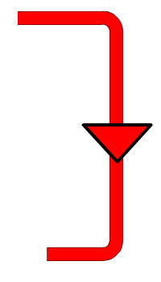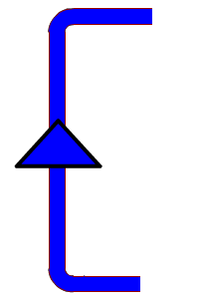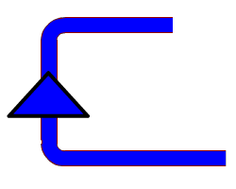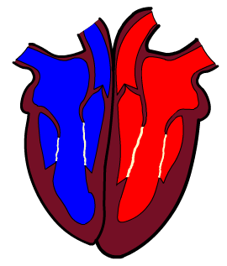AO1

Name the blood vessel and state their characteristics
AO2

Explain the differences between arteries and veins. Include the differences in their characteristics and the pressure which they are put under when carrying blood (6 marks)

What is the role of valves in the heart?
What is systole?

What is diastole?

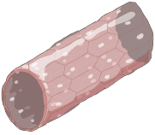

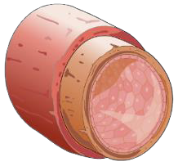AO1 AO3

